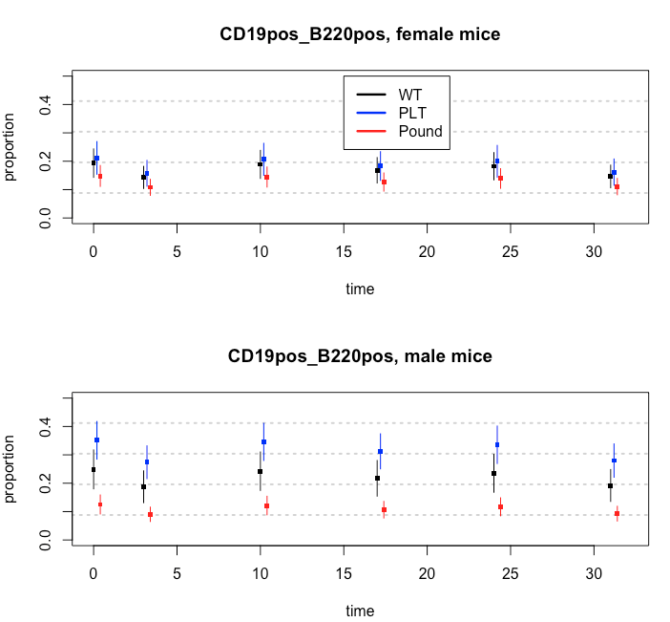

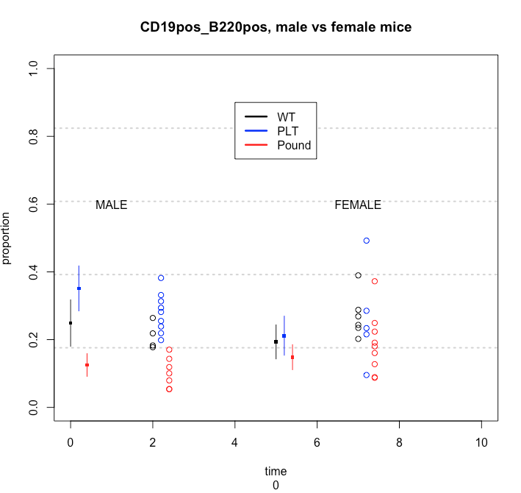

Credible Regions (segments) and data (balls)

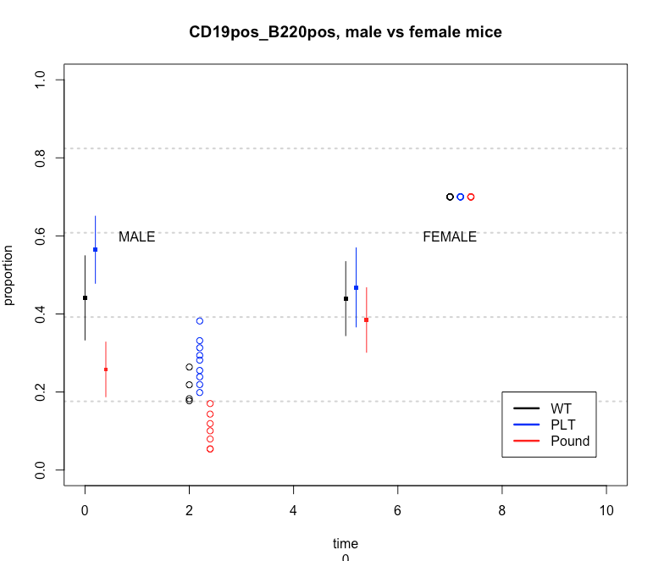

Is there life on earth: Set all Female datapoints to 0.7 Male CR’s also shift up.

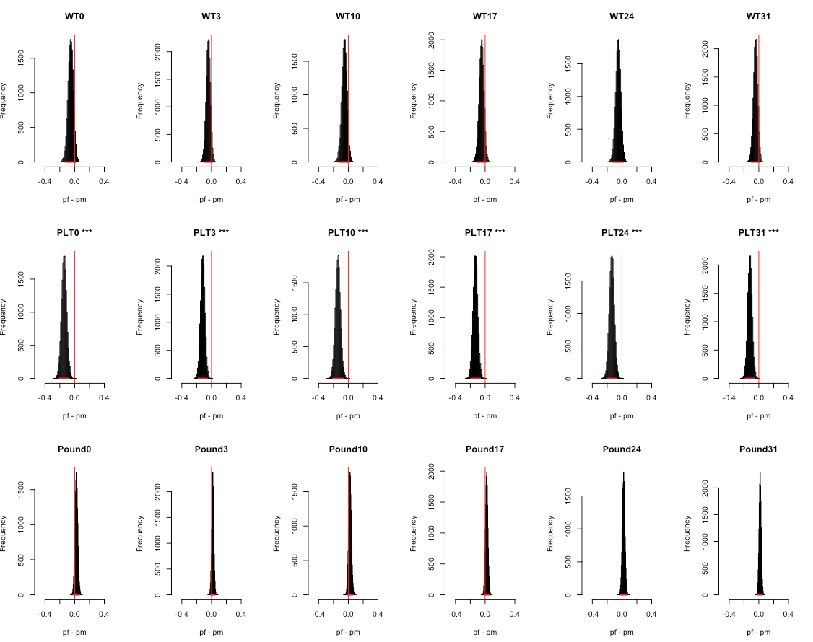

**female are all .7**

cr <- plot_posteriors(alpha1_sample,'a1, female')

2.5% 97.5%

0.6271187 1.6048501

> cr <- plot_posteriors(alpha2_sample,'a2, PLT')

2.5% 97.5%

1.092495 2.634277

> cr <- plot_posteriors(alpha3_sample,'a3, Pound')

2.5% 97.5%

0.2759208 0.6833301

> cr <- plot_posteriors(alpha4_sample,'a4, time 3')

2.5% 97.5%

0.1617812 0.3475310

> cr <- plot_posteriors(alpha5_sample,'a5, time 10')

2.5% 97.5%

0.2256714 0.4972927

> cr <- plot_posteriors(alpha6_sample,'a6, time 17')

2.5% 97.5%

0.1951619 0.4215772

> cr <- plot_posteriors(alpha7_sample,'a7, time 24')

2.5% 97.5%

0.2170661 0.4641707

> cr <- plot_posteriors(alpha8_sample,'a8, time 31')

2.5% 97.5%

0.1663951 0.3602133

> cr <- plot_posteriors(beta1_sample,'beta1, female*PLT')

2.5% 97.5%

0.3632158 1.2401768

> cr <- plot_posteriors(beta2_sample,'beta2, female*Pound')

2.5% 97.5%

1.019434 3.344619

mean(alpha0_sample)

[1] -1.144738

> mean(alpha1_sample)

[1] 0.003736903

> mean(alpha2_sample)

[1] 0.5272376

> mean(alpha3_sample)

[1] -0.837072

> mean(alpha3_sample)

[1] -0.837072

> mean(alpha4_sample)

[1] -1.443995

> mean(alpha5_sample)

[1] -1.097427

> mean(alpha6_sample)

[1] -1.249253

> mean(alpha7_sample)

[1] -1.145649

> mean(alpha8_sample)

[1] -1.408239

> mean(beta1_sample)

[1] -0.4071876

> mean(beta2_sample)

[1] 0.6015056

**Now not setting them to 0.7: the real data**

> cr <- plot_posteriors(alpha1_sample,'a1, female')

2.5% 97.5%

0.4850923 1.0885548

> cr <- plot_posteriors(alpha2_sample,'a2, PLT')

2.5% 97.5%

1.152467 2.452919

> cr <- plot_posteriors(alpha3_sample,'a3, Pound')

2.5% 97.5%

0.2882126 0.6265020

> cr <- plot_posteriors(alpha4_sample,'a4, time 3')

2.5% 97.5%

0.5003284 0.9422755

> cr <- plot_posteriors(alpha5_sample,'a5, time 10')

2.5% 97.5%

0.710129 1.322648

> cr <- plot_posteriors(alpha6_sample,'a6, time 17')

2.5% 97.5%

0.6047658 1.1459388

> cr <- plot_posteriors(alpha7_sample,'a7, time 24')

2.5% 97.5%

0.6803902 1.2748908

> cr <- plot_posteriors(alpha8_sample,'a8, time 31')

2.5% 97.5%

0.5180044 0.9890039

> cr <- plot_posteriors(beta1_sample,'beta1, female*PLT')

2.5% 97.5%

0.387880 1.126438

> cr <- plot_posteriors(beta2_sample,'beta2, female*Pound')

2.5% 97.5%

1.005684 2.800085

> mean(alpha1_sample)

[1] -0.3079304

> mean(alpha2_sample)

[1] 0.5192011

> mean(alpha3_sample)

[1] -0.8393008

> mean(alpha4_sample)

[1] -0.370753

> mean(alpha5_sample)

[1] -0.02931279

> mean(alpha6_sample)

[1] -0.1818387

> mean(alpha7_sample)

[1] -0.07403493

> mean(alpha8_sample)

[1] -0.3384968

> mean(beta1_sample)

[1] -0.4188116

> mean(beta2_sample)

[1] 0.509313